Session Border Controller (SBC) Resiliency

Table of Contents
Do Nothing 2
Solution Description 2
Solution Architecture 3
Risks 4
Cost 4
Recommended Approach 5
Solution Description 5
Solution Architecture 6
Risks 7
Cost 7
Future State Approach 7

Do Nothing

Solution Description
In January 2024, Session Border Controller (SBC) were introduced to support Transamerica's remote call centers located in India, South Africa, the Philippines, and mainland USA. Due to the Unified Communication team's lack of expertise and time constraints, they enlisted the help of a trusted third party, C1, to manage the deployment. However, the rapid rollout and limited knowledge of the service led to several incidents that revealed some shortcomings, which could be addressed through an updated deployment
The current solution architecture consists of two standalone SBCs, one located in the Cedar Rapids Data Center and the other in the Raleigh RTP DR facility. These SBCs are configured in an active/active setup, with the load evenly distributed between the two for users requiring this connectivity. The appliances are positioned in the DMZ at both locations to handle connections from users accessing via the internet or a dedicated MPLS circuit for the EXL group.
End users utilize the Avaya Agent for Desktop soft client on their local, non-Aegon supported workstations to initiate communication, which provides the audio stream for customer service agents. Phone controls (hold, mute, transfer) are managed through a login to the same soft client on the Azure Aegon Supported VDI. Inbound traffic passes through the DMZ-level firewall (ADC-EXTRA-NG-FW1 and RTP-NG-FW1) and, upon attempting to authenticate, hits the secondary firewall (ADC-ECOM-NG-FW1/2) to confirm the end user's login credentials.
The authentication of remote clients, which requires multi-factor authentication, occurs exclusively at the Cedar Rapids location and is not load balanced to Raleigh. Manual intervention is needed to redirect traffic to Raleigh. Once multi-factor authentication is completed, the agent’s extension/password is encrypted, enabling single sign-on to access the soft client. This process logs the user into both the Cedar Rapids and Raleigh SBCs, ensuring that in case of a failure at either location, the agent loses the call but the next call is routed from the opposite location that remains operational. The extension/password is encrypted and is passed to the client so the users no longer need to know or provide login information related to their extension number.
The current design limitation is its dependence on the Cedar Rapids location being online to support the MFA Authentication Process. Any outage would necessitate manual intervention to redirect users to Raleigh while efforts are made to restore Cedar Rapids’ functionality.

Solution Architecture
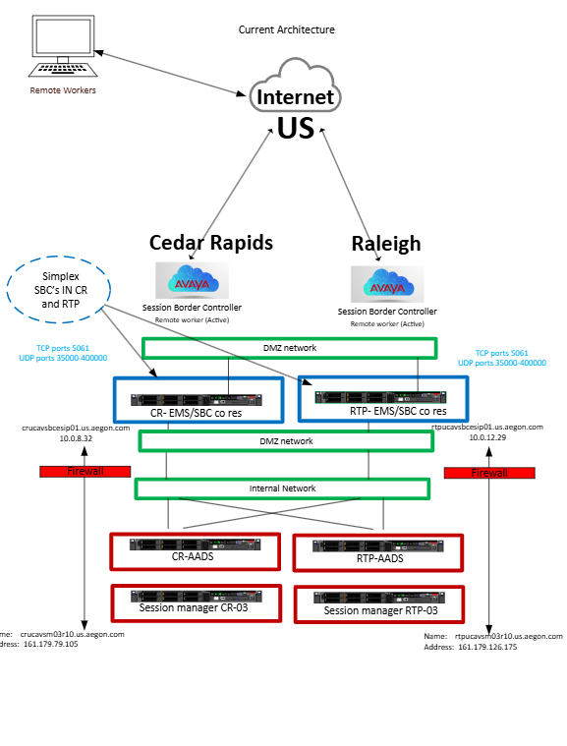

Risks
Currently the biggest risk to the current state is the reliance on the Cedar Rapids location always being online. Any failures as indicated would require manual intervention vs automated fail over to the Raleigh site. This has been witnessed with the various critical incidents that have been reported with the TA remote workers when the current SBC who run in simplex mode have crashed and caused all remote workers not being able to work.

Cost
There are no additional costs for the current state as this has been implemented and in production since January of 2024 and no further updates will be done. The recommended solution architecture will document the future state that will have costs associated with providing a better service to TA and its agents.

Recommended Approach

Solution Description
The future state solution architecture design includes high availability appliances and load balancers. The plan involves adding six new high availability appliances across both sites across separate VM Hosts. These devices will replace the existing ones operating in simplex mode. This addresses the current design when a user’s are logged into CR and RTP today at the same time, but they are independent of each other and each site is simplex. Each location will be equipped with Active/Passive Session Border Controllers, ensuring that any failure in the active SBC will trigger a failover to the standby node, allowing calls to continue rather than being dropped as in the current state architecture. Only if all nodes at one location fail will the call be dropped but the next call will be picked up at the other location to allow the agent to continue taking calls.
Additionally, an Element Management System (EMS) appliance will be deployed at each location to manage the devices supporting this solution. The EMS appliances will be separated out as individual units rather than co-residing with the SBCs as they do today. The session manager and AADS appliance will continue to operate independently, as they do in the current configuration.
In front of the appliances, agents will interact with an F5 load balancer for authentication and logging into their phones with preference to the CR location. We configure a health check that sends requests to AADS. This ensures accurate load balancing and prevents traffic from being directed to unhealthy AADS nodes
Clients will access the DNS through the GTM and will be directed to either the Cedar Rapids or Raleigh load balancer for authentication. Once authenticated, SIP signaling will be established in both Cedar Rapids and Raleigh, with failover to the passive node at the respective location in case of any failures at the local level.
we would like F5 w prefer CR but can check health before failing over to RTP_ -To ensure the health and availability of Avaya Aura Device Services (AADS when using an F5 load balancer,
The updated version of the code will include enhanced logging and monitoring in compliance with the GTS standard toolset managed by Team Neptune. This improvement will provide better proactive visibility and action before agent impact occurs.

Solution Architecture
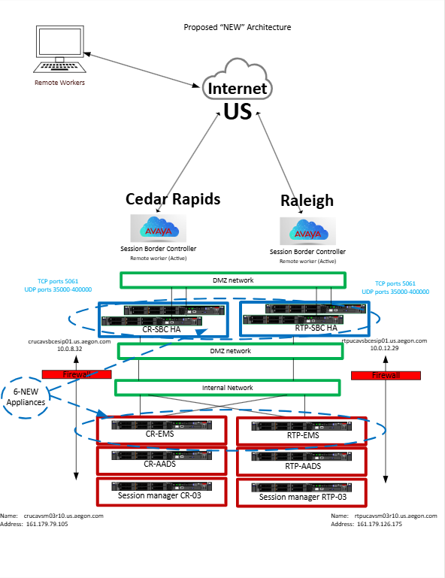

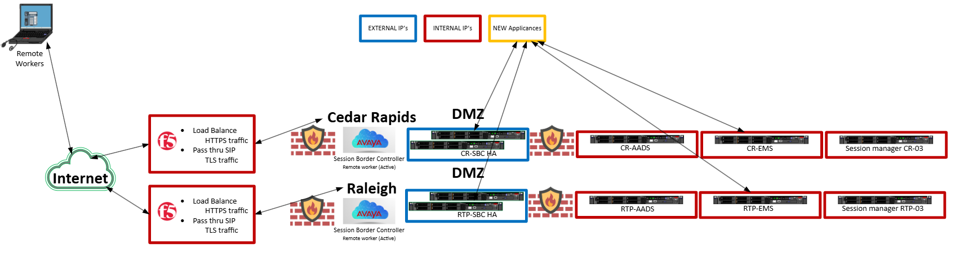

Risks
The risks identified in the current stated are being addressed in this section and it is the belief that this will significantly reduce the issues seen with the current state and provide a better service to our agents.

Cost
Load Balancer: ADC/EDC: $0 when using existing F5
Cost for replacement appliances outlined in the recommended solution

Base cost is $54 "Application Server - Large Tier (up to 8 CPU and/or 32GB memory)
"DS-Backup Tape Rec" cost is $6.72
"DS-Standard SAN" cost is $12.50
Total monthly cost is $73.22/per Server

No additional licensing costs are expected to be incurred.

Future State Approach
The recommendation following the implementation of the suggested approach is to update the desktop agent client to the Avaya Workplace client. This will provide agents with a newer soft phone interface. The reason for not introducing this change immediately is to avoid excessive modifications. Since the new interface differs from the current one, a training cycle will be necessary before implementation.

